Interpretation service is now available at HOUTERASU, Japan Legal Support Center!
English, Chinese, Portuguese, Spanish and Tagalog
Consultation for: Dept, Divorce, Work, Accident etc
Disaster related counseling is also accepted.
Non-Japanese Users
Ofifce Visit (No need to bring your own interpreter)) ※Phone consultation is not available
HOUTERASU district offices (65 offices around Japan)
Business hours: from 9am to 5pm on weekdays
we offer information based on user’s inquiries, on counseling counters for authorities concerned such as the legal system and bar associations etc at no charge.

Handing over of Phone

Interpreter
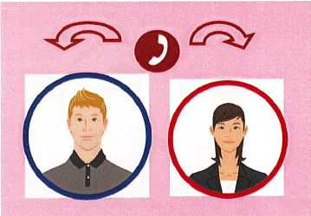
Users Our staff
- We will call our over-the-phone interpreter while users are in our office.
- What users say to the over-the-phone interpreter in one of our supporting languages will be interpreted and relayed to our staff in Japanese.
- Our staff gives a response for your inquiry to the over-the-phone interpreter in Japanese
- The over-the-phone interpreter will interpret and relay what our staff says to users in one of our supporting languages

※We also provide various aids such as providing free professional legal consultation and reimbursement for fees such as legal fees to those who have limited funds. (The screening is required.)


